Drone Video by Douglas Manning Showing the Northland Solar Project Site and Surroundings

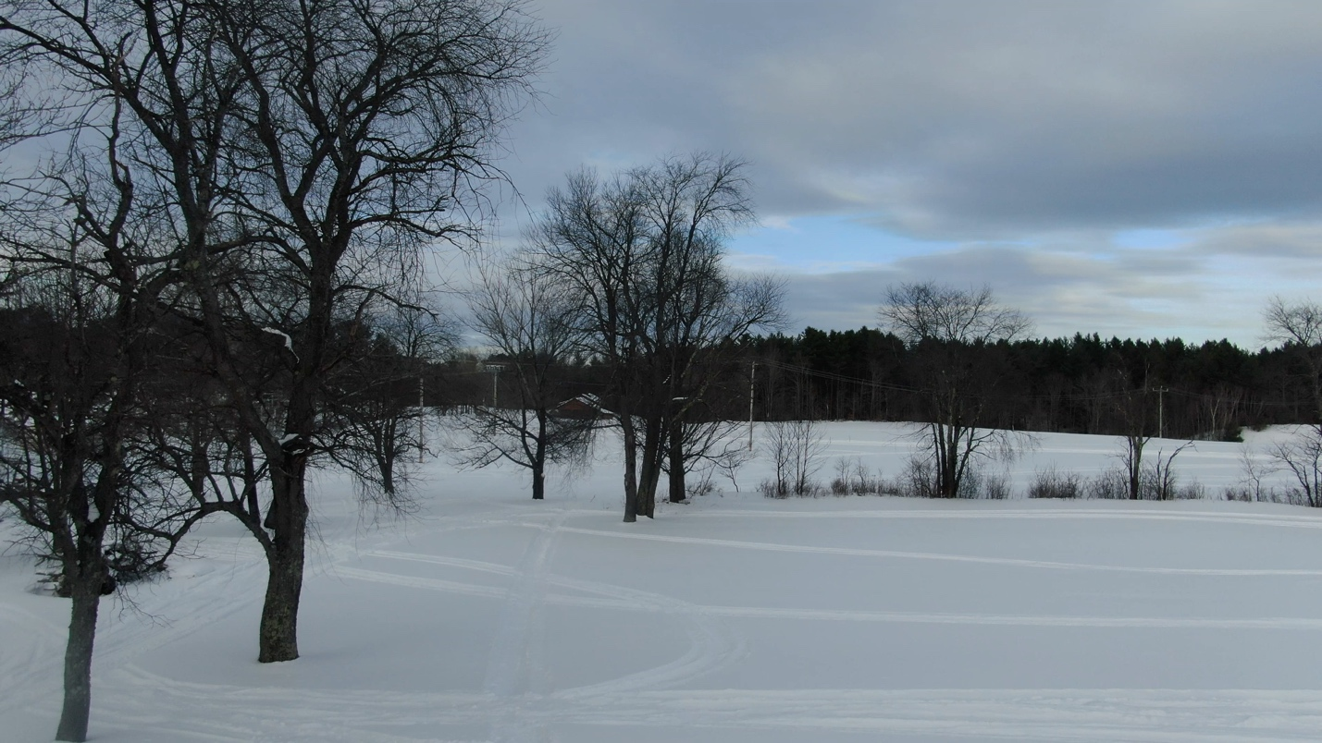

https://vimeo.com/1172529808?share=copy&fl=sv&fe=ci

