My name is Carrie Hathaway. My husband, David, and I own the 1798 brick farmhouse on the corner of 22A and Panton Rd. We have been tirelessly working on restoring it over the last few years. The city council recently approved our request to apply for tax increment financing to also put the infrastructure in for a 5-home development in the back.
The Vermont Public Utility Commission governs the approval of battery energy storage systems (BESS) through its authority under 30 V.S.A. § 248. According to this section, “the Vermont Division for Historic Preservation (VDHP), acting as the State Historic Preservation Office (SHPO), conducts its reviews pursuant to Criterion 8: Aesthetics, Historic Sites and Rare or Irreplaceable Natural Areas. Project review consists of evaluating the project's potential impacts to historic buildings and structures, historic districts, historic landscapes and settings, and known or potential archeological resources.”
The BESS project proposed for 99 Panton Road in Vergennes directly abuts two of Vergennes’ historic sites as identified in the Vergennes downtown walking tour: 78 West Main St. and 94 West Main St.
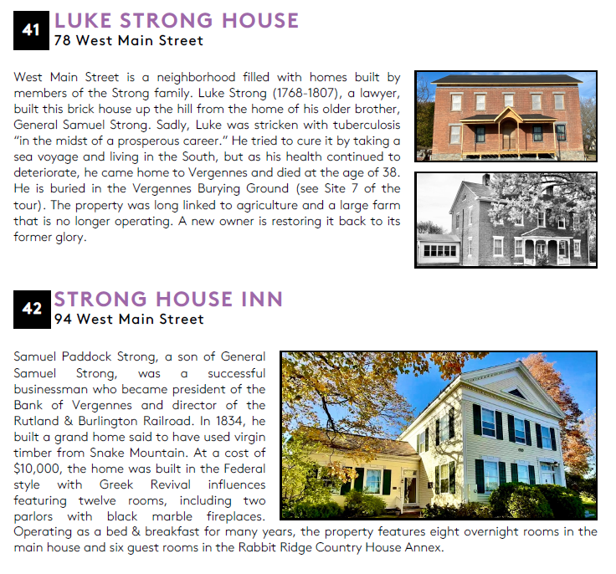
There are also three key criteria within § 248 that are particularly in conflict with this proposal: (1) Safety and Fire Codes; (2) Permitting and Land Use; and (3) Socio-Economic.
Safety and Fire Codes: this section requires adequate spacing between containers and fire buffers and must demonstrate that they will not create an undue burden on local fire or police services. Permitting and Land Use mandates that these projects should have minimal visual impact, and the Socio-Economic and Operational section states that land-use compatibility and noise impacts need to be strongly evaluated.
The proposed siting for this facility is directly downhill from a 5-home development recently approved to move forward by the city of Vergennes and directly abutting the two previously referenced historical homes:
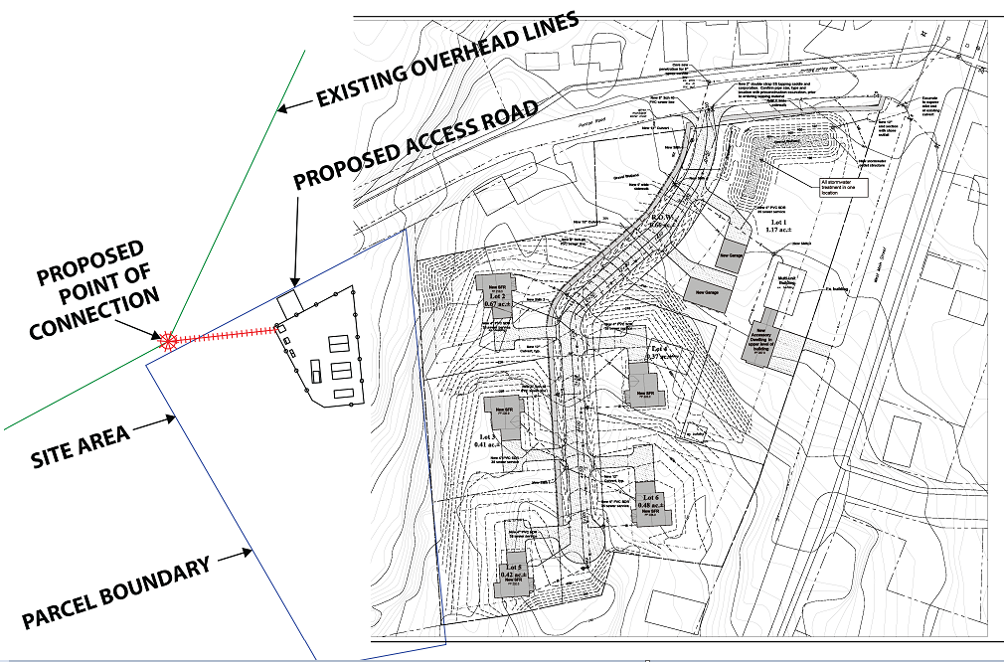
The (pseudo) public notice sent to abutting landowners erroneously stated “The Project fence is located approximately 40-ft from Panton Road and about 150-ft from the nearest residence. There is vegetation between the Project and residences to the north, east, and south that will remain and will buffer and filter views of the Project from residences on Panton Road, West Street, and W. Main St. …”
The Project had no authority to speak on the existing vegetation as the predominance of the vegetation growth is located on the 78 West Main St. property, not on the Project property. And to reiterate: given that the proposed siting is downhill of this locale, once clear cut to accommodate the 5-home development, the view from these new homes would be atop the facility with no buffer at all. Additionally, there will be no way to mitigate the noise emanating from the system, especially since “noise” travels uphill and will be amplified on uphill home sites. And the 150-ft. reference is to the home shaded out in the image above (please see red arrow above). Clearly the new homes planned are much closer (marked by the green arrow). There is also no other spot on the abutting parcel where mitigation could be proposed.
These types of facilities also have a history of fire. While systems have improved over recent years, that threat still exists:
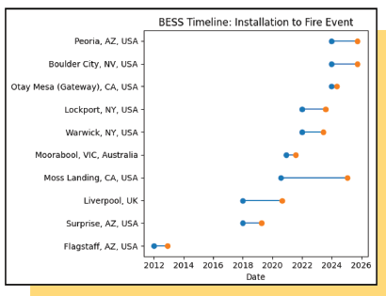
Vergennes has a volunteer fire department. The station is located at 50 Green Street in the city which is across the Otter Creek from the proposed siting. The only bridge in the vicinity is extremely old, narrow, congested, and has been identified as in need of repair. When on fire, BESS systems emit toxic fumes, often require evacuations, and are extremely difficult to contain when an incident occurs. While the firefighters in Vergennes are very dedicated to their calling, having a volunteer crew respond immediately to an incident is problematic. Additionally, § 248 requires buffering to aid in addressing fire concerns. There will be no buffering once the development is underway.
Based on these factors for consideration, I implore the city planning commission, the city council, the city officials, and the local legislators to comment publicly on the e-PUC website (https://epuc.vermont.gov) on case number 25-3076-AN and have city officials notify the state as to their intention to intervene on this proposal.

