 | Stowe Electric Department  PO Box 190  435 Moscow Rd  Stowe, VT 05672  802-253-7215  www.StoweElectric.com

Cost Estimate for Connected Homes EV and EVSE Program

The fixed costs for the utility enrollment into Connected Homes are a one-time onboarding fee of $2,655 paid to MMWEC, a $7,500 annual fee paid to VP, and a $3,500 annual fee paid to MMWEC. The annual fees are attributed to MMWEC and VP administrative costs to manage device enrollment and make peak curtailment calls. Variable costs to SED are the incentives paid to customers for participating in curtailment calls. MMWEC provided the following table to estimate customer participation in the Connected Homes Program based on their member utilities current participation levels.
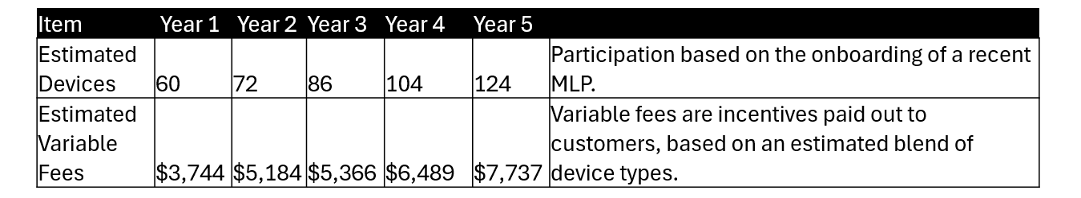
MMWEC estimated the return on the investment to the utility, which is based on reducing the utility's electric load during system peak events, as follows:
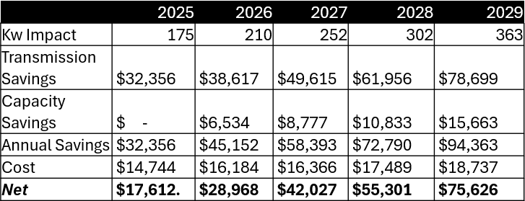
The table above shows Yr 1 costs as $14,744 and a power supply savings of $32,356. This shows a net positive program in Yr 1 as $17,612 in savings to the utility. There are no capacity savings in Yr1, but this will add an additional cost savings to the utility. This Table also does not capture the potential cost savings to SED for curtailing demand during VELCO system peaks, which will add an additional cost savings to SED over the life of this Project. The table shows that over a 5-year timeframe the Program will provide a positive net benefit to SED and its customers.

