Town of Tinmouth
Select Board and Planning Commission
515 North End Road, Tinmouth, VT 05773
tinmouthtown@vermontel.net

June 26, 2025
Re: 25-0316-AN
Applicant: Industrial Wireless Technologies, Inc. (“ITW”) 440 Route 140, Tinmouth, VT on documents received by the Town
Applicant: Industrial Tower and Wireless, LLC posted on ePUC website
This letter is in response to the filing by Industrial Wireless Technologies, Inc. on February 12, 2025 and its revised filing dated May 28, 2025 received from W. Cooper Hayes, Esq at MSK Attorneys of Burlington, VT.

This project proposes to erect a 160 foot communication tower with an additional 13 feet of antennas on its top located at 440 Route 140 in Tinmouth. It is located in the Conservation District identified in the Tinmouth Zoning bylaws, just outside the Protection District. The Town appreciates the applicants’ adjusting the location out of the Protection District which allows only agriculture and forestry uses. It is still very close to the largest Class I wetland in the state. And is located at the southern end of Vermont Fish & Wildlife’s Tinmouth Wildlife Management Area, which encompasses over 1200 acres in the belly of our valley. The Tinmouth Channel winds its way through this vast area – when one is in a canoe it is like being in a world apart – only one dwelling is visible. Our town has many scenic vistas, including Route 140 as it winds it way across the valley into the center of town. This facility would tower above anyone approaching it. The intersection of Route 140 and the East Road are included as a Scenic Resource in our Town Plan.

Tinmouth first adopted a Town Plan in 1974. The vision then and now is to maintain the rural aspects of the town including active productive farms, open meadows, substantial forests, and scenic mountain vistas. Objectives of the original Plan continue to this date, including preserving the rural character of Tinmouth; protecting and preserving scenic and historic features, open spaces, fragile and wildlife habitats and other natural resources; and prohibiting incompatible and uncoordinated development activity.

Telecommunication bylaws are part of our zoning bylaws which were adopted to implement the policies of the duly adopted Town Plan. Objectives therein include preserving the rural character of Tinmouth; protecting and preserving scenic and historic features, open spaces, fragile areas and wildlife habitats and other natural resources; and requiring that public utilities be located in such a way that they will not have an undue adverse effect on the scenic quality and land values of the town. Telecommunications Facilities are a Conditional Use under the bylaw – those standards include screening from roads and adjacent properties, and proximity of lots used for residential purposes, which this project cannot meet.

Wireless Telecommunications Facilities – Section 409 – includes protecting scenic qualities and minimizing visual impacts, and requirements include limiting the height to 130 feet and no more than 20 feet above the average tree line.

In addition, it is being located in the Conservation District: Description: Conservation areas contain lands that are sensitive to development. These include large regionally connected forested blocks, steep slopes (often with shallow soils), high elevations, wetlands, stream banks and wildlife corridors, as well as areas of scenic, ecological, cultural, or historic significance.
Its Purpose includes: To preserve the physical, natural, and scenic characteristics of lands in the district.

The Town Plan also includes a list of historic features/sites. The proposed tower would be sited across the road from Tinmouth's historic cemetery, where Nathanial Chipman, lawyer, US Senator, Chief Justice of the Vermont Supreme Court and one of those instrumental in the getting Vermont admitted as the 14th state, lies in rest, under a monument erected by State. The proposed facility would tower over the entire cemetery, which is unacceptable.

The Tinmouth Select Board and Planning Commission voted at a special meeting held on June 26, 2025 to find this project does not comply with the Tinmouth Town Plan or its telecommunication bylaws and recommends that the applicant not move forward with this tower application to the PUC for this location. This proposal does not preserve the rural and scenic qualities that so many residents and those from away appreciate.

The Town would consider working with the applicant to find an acceptable location.

Thank you for your consideration.

Select Board Chair s/Kevin Eaton
Kevin Eaton

Planning Commission Chair s/Michael Fallar
Michael Fallar

Please see photo below.

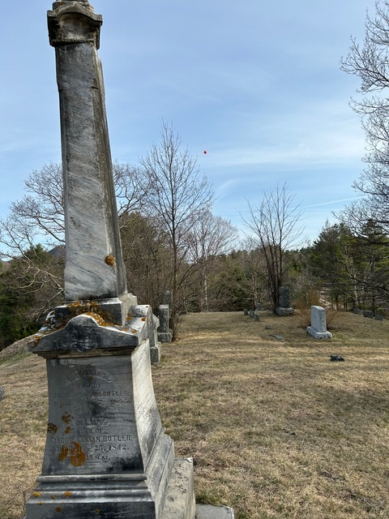
Balloon seen from the Tinmouth Cemetery

