Filed via ePUC

January 24, 2023

Holly Anderson, Clerk
Vermont Public Utility Commission
112 State Street, Fourth Floor
Montpelier, VT 05620-2701

Re: Case No. 21-2939-NMP, Randolph Davis Solar, LLC

Dear Ms. Anderson:

The Agency of Natural Resources filed a brief on January 12, 2023 in the above-referenced case. The Agency has since been alerted to a typographical error on the brief’s second page. The brief erroneously cites to 12 V.S.A. § 1264(f). The proper citation is 10 V.S.A. § 1264(f).

The Agency is filing a revised brief correcting this citation error. The revied filing does not change any other aspects of the initial brief, including the date of the document, given the minor nature of the revision.

Please contact me with any questions or concerns about this revised filing.

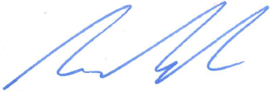
Sincerely,

Aaron Kisicki

