Revised Proposed Customer Notice
Name
Address
Burlington, VT xxxxx

____________ xx, 2022

Re: Proposed change to payments for “pre-existing” net-metering system solar incentive credits (Public Utility Commission Case No. 22-3947-TF)

Dear ______________________,

This correspondence shares what we hope you will find to be good news, and is a follow-up to a letter dated September 8, 2022 that referenced “Conclusion of payments for net-metering solar incentive credit balances” that you received from Burlington Electric Department (BED). In that letter, we informed all pre-existing net-metering customers who filed permits before January 1, 2017 that, on September 2, 2022, BED had filed with the Vermont Public Utility Commission (PUC) a proposed revised net-metering tariff. The revised tariff included a number of proposed changes, including a change to the tariff’s carry-forward (“credit expiration”) and cash-out (“refund”) procedures. Another proposed change was to return to the solar incentive amount that had been in effect prior to August 1, 2021.
In a September 30, 2022 order, the PUC approved most of the changes BED requested. One exception was the change to credit and refund procedures (found in Sections V.F.(5) and (6) of BED’s net-metering tariff) that would result in BED no longer being able to provide refunds to net-metering customers who accrue a solar incentive credit balance in excess of $100 as of October 1, 2022. The PUC delayed approval of the change to Sections V.F.(5) and (6).
One change approved by the PUC that became effective on October 1, 2022 was BED’s proposal to return the solar incentive amount to $0.052265 per kWh, which was the rate in effect prior to a change to $0.04118 per kWh on August 1, 2021. BED also had requested PUC permission to provide customers with refunds for the difference between the two amounts from the period when the credit was reduced to the date the credit returned to the higher level. The PUC has not yet ruled on this request; if approved, you will receive a credit on a future electric bill.
We appreciate the thoughtful outreach from many of our net-metering customers in response to the September 8 letter, in particular regarding the issue of credit expiration and refund procedures that led our team to engage in extensive research on this issue. The result of BED’s additional research has led us to determine that the change to the credit expiration and refund set forth in our September 2 PUC filing may not be required, and to advocate to the PUC for the continuation of credits and refunds for net-metering balances.
On October 14, 2022, BED filed a proposed final revised tariff with the PUC that retains the credit expiration and refund provisions included in Sections V.F.(5) and (6) of the tariff. If the PUC approves the October 14 revised tariff filing, BED customers will retain the ability to carry forward credits and get refunds for net-metering balances for the remainder of the 10-year period of time that began on the date of their solar array commissioning. The Section V.F.(5) and (6) provisions pertain only to pre-existing net-metering systems with permit filings that predate January 1, 2017 and will expire upon the 10-year anniversary of solar system commissioning.
Our team recognizes that Vermont’s net-metering process is complex and that the back and forth over changing rules adds to the complexity. We continue to be available to address concerns and questions and apologize for any inconvenience caused by the changes.
Customers may access the documents filed in Case No. 22-3947-TF by visiting ePUC.vermont.gov. Additionally, customers with questions may contact BED’s Customer Care Team at customercarehelp@burlingtonelectric.com or 802-865-7300.
Thank you.
Sincerely,
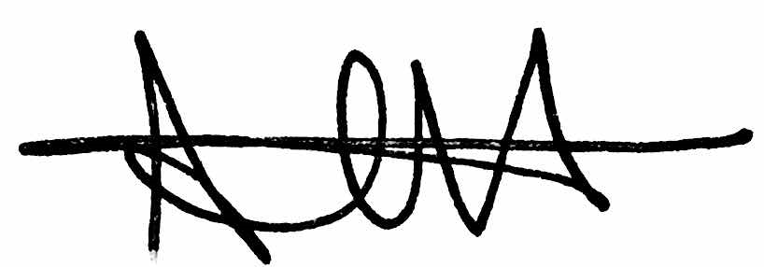
Andi Higbee
Director of Customer Care

