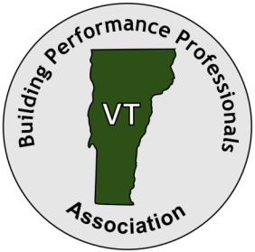
Building Performance Professionals
Association of Vermont

BPPA-VT
Vermont’s Authorities on Energy Efficiency
PO Box 8125, Brattleboro, VT 05304 • 802-522-4677 • www.BPPA-VT.org

February 28, 2020

Vermont Public Utility Commission
112 State Street, Suite 4
Montpelier, VT 05602

RE: Case No. 19-3272-PET

Dear Commissioners:

On behalf of the Building Performance Professionals Association of Vermont (BPPA-VT), I am writing to voice our strong support for the comprehensive Demand Resources Plan (DRP) Proposal submitted by Efficiency Vermont.

BPPA-VT is a business trade organization promoting and representing businesses of the weatherization industry in Vermont. We represent weatherization professionals who are certified under the rigorous standards of the Building Performance Institute, and participate in the EPA’s Home Performance and Building Performance with Energy Star Programs.

Our primary focus in these two programs is on Vermont’s existing homes and commercial buildings.
Efficiency Vermont has, over the years, been a strong sponsor and partner in our efforts to promote our work, to help us build our organization, and to develop and expand the reach and capacity of the weatherization industry in Vermont.

Through its Efficiency Excellence Network, Efficiency Vermont has supported our member businesses
- by providing training and workforce development,
- by providing technical and business assistance,
- through incentive programs for customers, and
- through important efforts to educate Vermont communities and promote our work in the marketplace.
- Important investments to continue and, more importantly, to expand these programs are included in the latest DRP request.

BPPA-VT is particularly excited to support Efficiency Vermont’s request to apply greenhouse gas emissions reductions as their primary performance standard moving forward. We see this as a critical structural shift necessary to properly address the problem of meeting Vermont’s CEP goal of 90% renewable by 2050. It will have a significant impact on how resources such as incentives, education, marketing, and workforce development efforts are distributed. This shift will support both our traditional building efficiency efforts, and the development of new programs such as our Zero Energy Now initiative, which has the potential to drive deep greenhouse gas savings and significant workforce and industry growth in all parts of Vermont.

BPPA-VT values our ongoing partnership with Efficiency Vermont, and we appreciate this opportunity to offer public comment on their DRP Proposal.

Thank you for your consideration.


Sincerely,

Jonathan Dancing
Executive Director
Building Performance Professionals Association of Vermont

